**Theory (Memory, Architectures, Interrupts and Stacks)**

1. Types of memory

***1.1. What is ROM and what is its primary purpose?***

ROM is Read Only Memory, and its primary purpose is to store information in a computer system that can only be read.

***1.2. What is RAM and how is it different from ROM?***

RAM stands for Random Access Memory and this type of memory stores data in the CPU and these data can be read, written, and erased various times. ***1.3. What is the difference between static RAM and dynamics RAM?***

Static RAM, being faster and occupying larger area of silicon per byte requires moderate power to keep retaining data. However, Dynamics RAM needs low power to operate, it occupies smaller area of silicon per byte and as long as the data and contents are being refreshed, it will keep on retaining data. ***1.4. What type of memory is typically used in USB thumb drives? Why shouldn’t we rely on this for critical data storage?***

Flash Memory- EEPROM (electrically erasable programmable read-only memory). The life expectancy heavily depends on the write and erase cycles and once it reaches that limit, there may be distortion and even loss of data.

1. ***Consider a computer with 1GB RAM (1024 MB). Given memory addressing is for each byte, how many bits are needed to address all bytes in the system’s RAM?***

1 GB = 1024 MB = 1024 * 1000000 * 8

= 8 192 000 000 bits

1. ***Give a brief description of the Von Neumann and Harvard computing architectures. What are the fundamental differences between the two and for what is each designed to achieve?***

The Von Neuman Architecture(cheaper) is capable of storing all program elements in the same memory location: Data and instructions whereas Harvard Computing Architectures (Faster and more secure but is expensive) consist of two memory locations, one for data and one for instructions.

1. ***What is cache memory and what is its primary role?***

The Cache memory is an additional memory that can temporarily stores frequently used data and instructions to speed up the functions of a CPU.

1. ***Explain the concept of an interrupt, and list four common types.***

Device connected to a computer or a program within the computer emit a signal that will require software’ s attention.

Common types of interrupts are network, clock, mouse and error.

* 1. ***Polling is an alternative to interrupts? Briefly explain polling and why it is not commonly used.***

Basically, Polling checks the state and input of each hardware devices in an ordered sequence. If required, it can also keep update related to changes and inputs within the computer system.

1. ***Explain the general concept of a stack - how do they work, and what is their primary purpose.***

Stacks allow a way to access memory within a computer system in an ordered technique without random access. Push adds an element to the stack collection, and pop, removes the most recently added element that was not yet removed.***6.1. How are stacks useful for handling interrupts?***

***6.2. How are stacks useful in programming?***

Programming consists of a series of functions and codes that need to be executed in an ordered way where the concepts of stack has been used. Hence, this stack may help for undo processes where the most recent functions can be undone when required.

**Stack 5-bit deep, 1-bit wide (From Right to Left)**

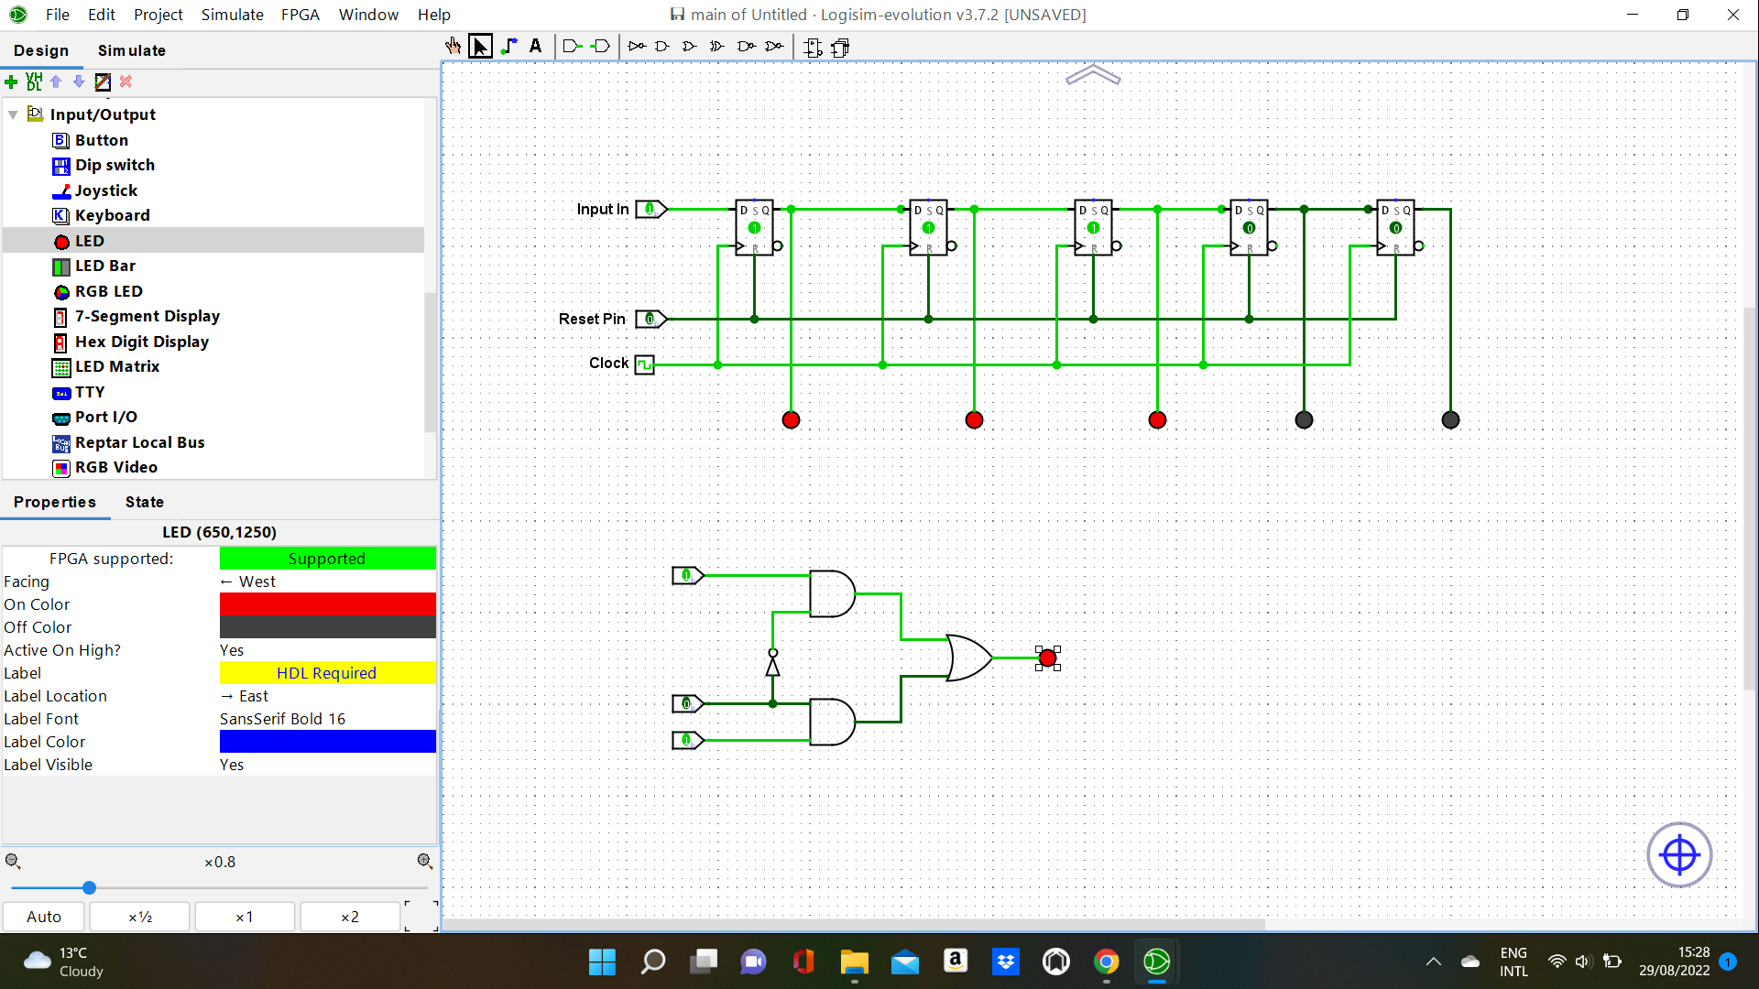

**Stack 5-bit deep, 1-bit wide (From Left to Right)**

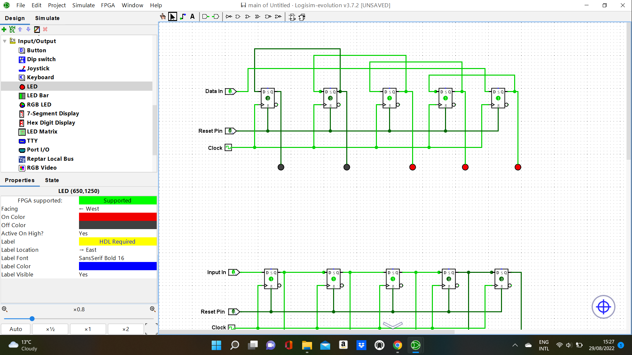

**Encoder**



**Bi-directional shifting encoder**

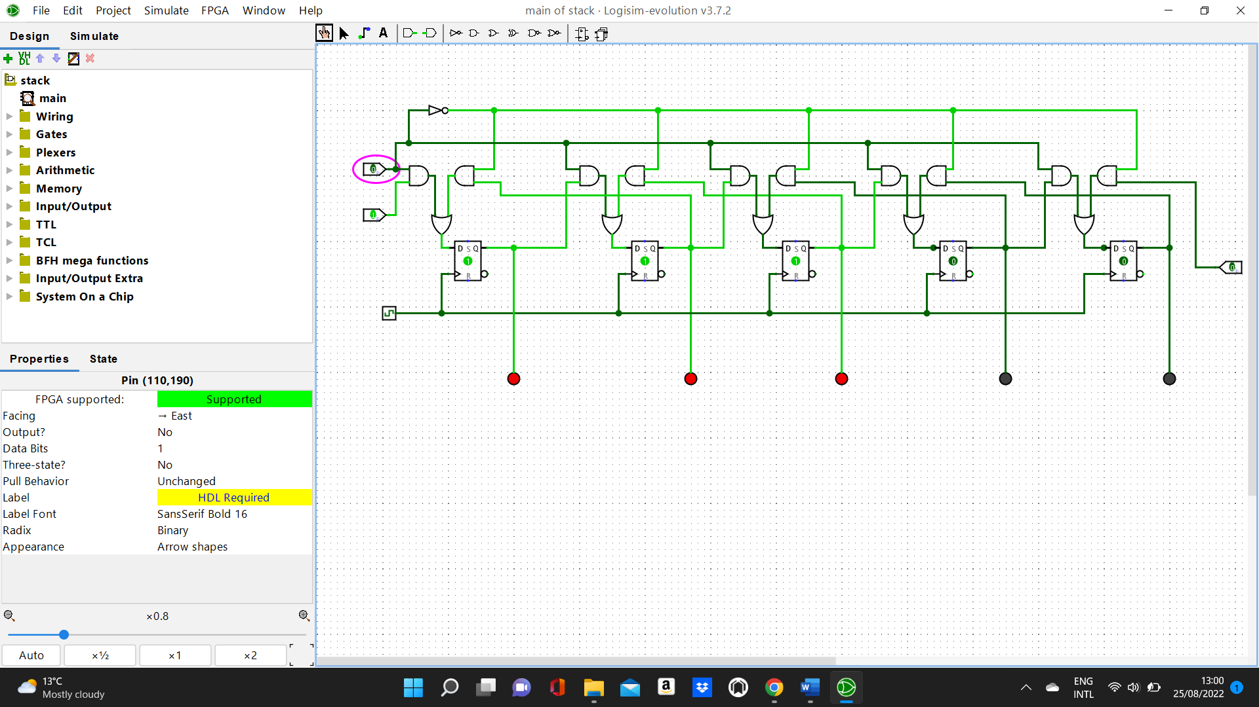

**Bi-directional shifting encoder with Register**

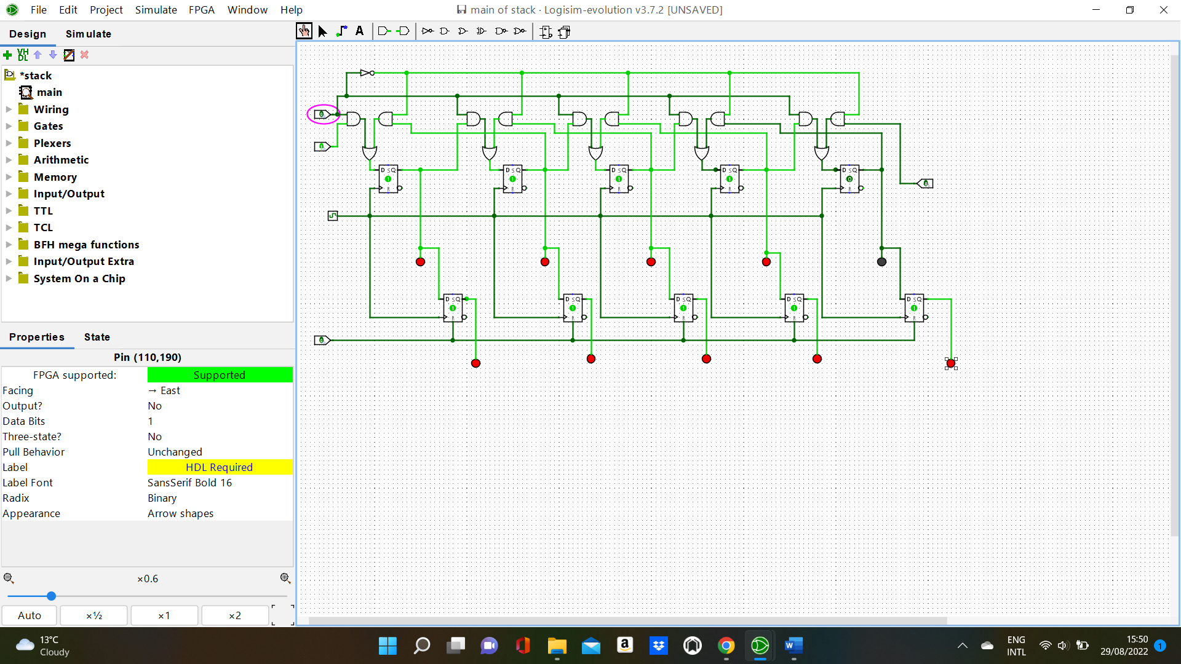

https://www.slideshare.net/AkarshMishra9/digital-alarm-clock-digital-design-design-assignment